Math 4 Name__________________________________

**2-3 Solving Systems with Matrices**Date___________

Learning Goals:

* *I can use determinants to find whether a matrix is invertible.*
* *I can use matrices to solve systems of linear equations.*
* *I can use matrices to encode and decode messages*.

I. In Lesson 2-2 you learned about properties of matrices. In this lesson we will further develop the idea of the **inverse of a matrix**.

1. If a matrix has an inverse, it is called **invertible** (or **nonsingular**); otherwise, it is called **singular.** Remember**,** only a square matrix can have an inverse. But not all square matrices have inverses. If, however, a matrix does have an inverse, that inverse is unique.
2. To determine if a matrix has an inverse, we can use something called its **determinant**. The determinant of a 2 × 2 matrix is defined as follows:

**Definition of the Determinant of a 2 × 2 Matrix**

If *A* = the determinant of the matrix is given by:

det(*A*) = 

1. Given . Use the formula above to calculate |*A*|.

**\*\*\*If the determinant of matrix ≠ 0, then the matrix has an inverse.**

Based on your computations, does *A* have an inverse? ______________

1. To find the inverse of a 2 × 2 matrix, we use the following formula:



If then,

1. Looking at this formula, explain why it makes sense that a nonsingular matrix must have a nonzero determinant.
2. Use the above formula to find *A*-1 (for #2, part A).
3. Now use your calculator to verify what you found in #2.

Page 2

II. Why is the inverse of a matrix so important? You will see in this next section . . . . .

A. Solve the system of equations below using the method of your choosing.



B. Solving a system using the Inverse-Matrix Method:

In previous courses you learned multiple methods of solving a system of equation: graphically,

substitution, and linear combinations. The Inverse-Matrix Method is yet another process.

1. 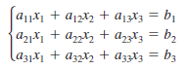The Inverse-Matrix Method Matrix uses matrix multiplication to represent a system of linear equations. Note how the system

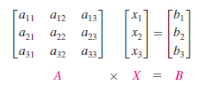can be written as the matrix equation *AX = B* where *A*  is the *coefficient matrix* of the system, and *X* and *B* are column matrices.

1. Solving a system using matrices boils down to setting up and solving a matrix equation. Note the similarity to solving a linear equation to that of a matrix equation:

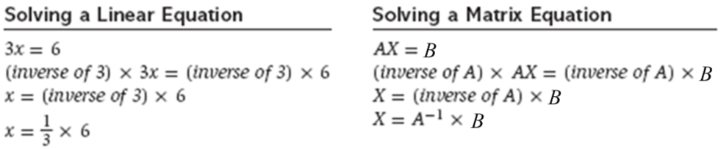

Page 3

1. Let’s see how this works. Study the following example:

Consider the following system of linear equations.

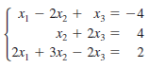

1. Write this system as a **matrix equation**. *AX = B.*

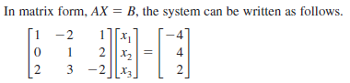

*A ● X = B* **Solution Matrix**

1. Solve the matrix equation for *X*. *X = A-1B.*

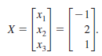 

-1

= ● 

*X = A*-1 *● B*

1. Solve the following system using the Inverse-Matrix Method.



* 1. Write the system as a matrix equation.



*A ● X = B*

* 1. Use your calculator to solve the matrix equation for *X*.



Solution Matrix:

**\*\*\*2-3 Homework is on the next page!!**

Page 4

**Lesson 2-3 Homework**

\*\*\**Please show your work on a separate piece of paper.*

1. Without using a calculator, show that *B* is the inverse of *A.*

**

2. Without using a calculator, find the inverse of each matrix (if it exists).



*A* = *B = C =*

***Use your calculator for the remaining problems.***

3. Use the Inverse-Matrix Method to solve the following systems (if possible).

*You must write the matrix equation as well as your final solution matrix.*

**

a. b.

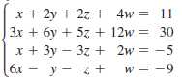

c.  d.

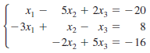

e.  f.

Use the Inverse-Matrix Method to solve the following problems.

4. A serving of roast beef has 17 grams of protein and 11 milligrams of calcium. A serving of mashed potatoes has 2 grams of protein and 25 milligrams of calcium. How many servings of each are needed to get 40 grams of protein and 97 milligrams of calcium?